Transition
Get ready for Science!
- On a visit to a park or on a walk, find a tree and collect a leaf. Use books or the Internet to identify the tree from the leaf. In the space below, draw the leaf and label as many parts as you can.
- Find a flower/plant outside. Draw and label it. What does the flower/plant need to grow?
- Look for the nutritional on the wrappers or bottles. Fill in the table below with the nutritional information about the bars or drinks.
Name of chocolate bar or drink | Carbohydrates (per 100g) | Fats (per 100g) | Protein (per 100g) | Calories
- Which of the chocolate bars or drinks is the healthiest? Use your table to help you decide.
- Produce a fact file on one of the following famous Scientists: Charles Darwin, Marie Curie, Ada Lovelace, Mae Jemison. Include: Name, Birthday, where they are from, what they did and draw a picture
- Chemists make materials that are suitable for their purpose. In this activity, you will work out why objects are made from certain materials.
What to do
• Find five objects at home that are made from different materials.
• Fill in the table to show why the objects are made from their materials. The first line is already filled in.
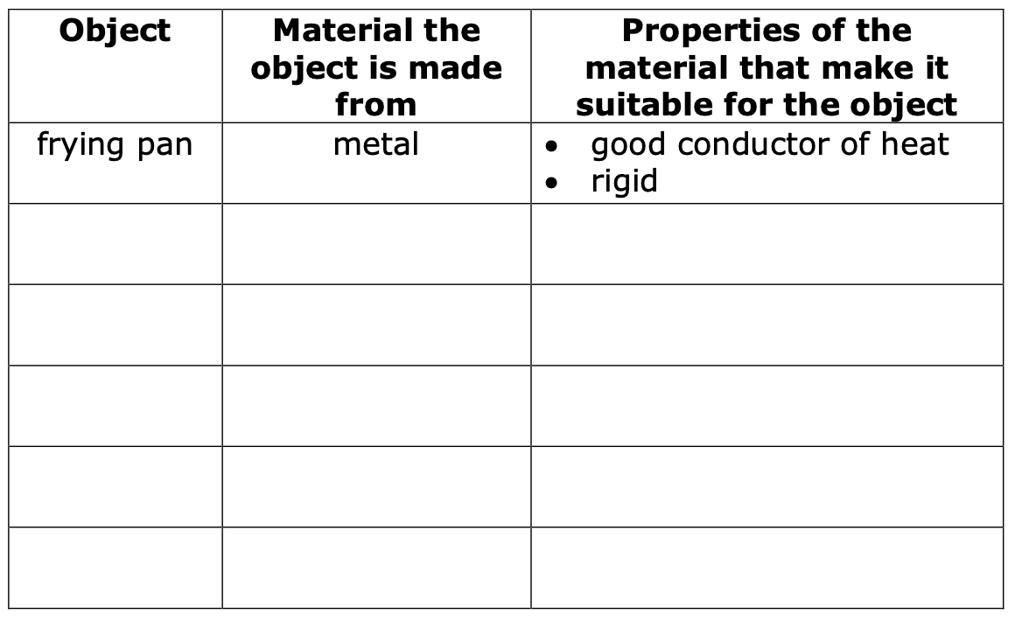

- Check the Sun’s position several times in one day and write the changes. Warning: Never look directly at the Sun!
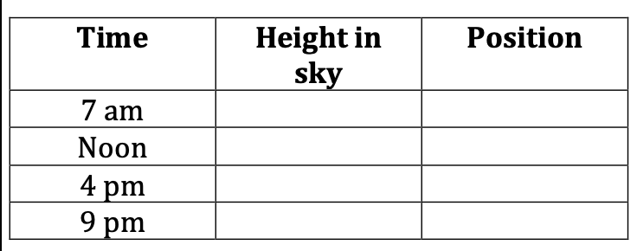

- List some objects that are magnetic and some that are not
- Watch the moon every night for a week. Write down what it looks like each day. Think about its shape, and brightness.
- Research one of the 8 planets in our solar system! Draw a picture to accompany your research

Get ready for Practicals

Answer these questions using what you know about the human heart.
Where is the heart found in your body? .....................................................
What does the heart do? ..............................................................................
Your pulse measures how many times your heart beats in one minute. Your pulse goes up when you exercise.
- • Record your pulse when you are resting, and fill in the table.
- • Now jog on the spot or do star jumps for two minutes.
- • Measure your pulse again and fill in the table.
Resting pulse (beats per minute) | Pulse after exercise (beats per minute)

What is the effect of exercise on your pulse rate? Use your table to help you decide.
.................................................................................................................................................... .......................................................................................................................................................................................

